DISHES  Soups | 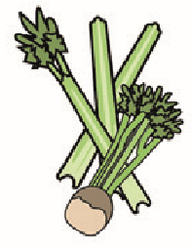 | 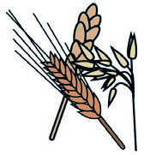 | 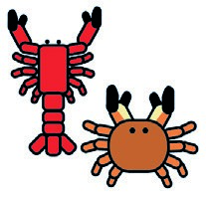 | 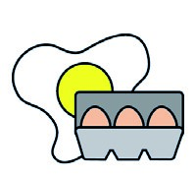 |  | 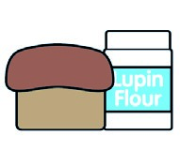 | 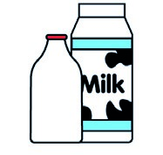 |  | 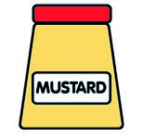 | 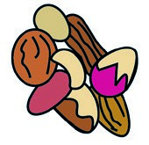 | 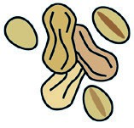 | 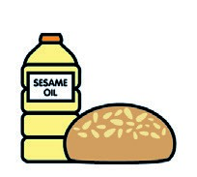 |  | 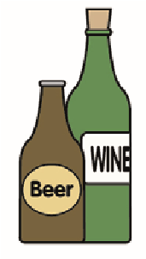
Allergens | Celery | Cereals containing gluten** | Crustaceans | Eggs | Fish | Lupin | Milk | Molluscs | Mustard | Nuts* | Peanuts | Sesame seeds | Soya | Sulphur dioxide
Lentil Soup | May Contain
Potato and Leek Soup | May Contain
Chicken Noodle Soup | May Contain | Spaghetti and noodles contain wheat.  Can use GF |  | If using Noodles |  | If using GF pasta |  |  |  |  |  |  | If using GF pasta
Tomato Soup | May Contain
Minestrone Soup | In soup |  |  |  |  | If using G/F pasta |  |  |  |  |  |  | If using G/F pasta
Cauliflower Cheese Soup | May Contain |  |  |  |  |  | In Cheese
Butternut and Tomato | May Contain

DISHES
Main Courses
Allergens  Fish Dishes | Celery | Cereals containing gluten** | Crustaceans | Eggs | Fish | Lupin | Milk | Molluscs | Mustard | Nuts* | Peanuts | Sesame seeds | Soya | Sulphur dioxide
Breaded Fish and Chips |  | In breadcrums
Salmon Fish Finger wrap with chips |  | In Wrap
Cod Dog |  | In Bun
Bubble Fish Fillet

DISHES
Main Meals
 | Allergens | Celery | Cereals containing gluten** | Crustaceans | Eggs | Fish | Lupin | Milk | Molluscs | Mustard | Nuts* | Peanuts | Sesame seeds | Soya | Sulphur dioxide
 | Beef Bolognaise | May Contain | In pasta |  |  |  | If using G/F pasta |  |  |  |  |  |  | If using G/F pasta
 | Chicken Meatballs with spaghetti in tomato and herb sauce | In meatballs | In pasta |  |  |  | If using G/F pasta |  |  |  |  |  |  | If using G/F pasta
 | Spanish Chicken | May Contain
 | Chinese Chicken Curry | May Contain
 | Chicken and Leek Pie | May Contain | In Sauce
 | Scottish Steak Pie | May Contain | In pastry
 | Chicken Casserole | May Contain
 | Mince and gravy | May Contain
 | Cheeseburger |  | In bun and burger |  |  |  |  |  |  |  |  |  |  |  | in primary school
 | Omelette tray bake |  |  |  | In omelette |  | In cheese

DISHES
Vegetarian and Vegan
Allergens | Celery | Cereals containing gluten** | Crustaceans | Eggs | Fish | Lupin | Milk | Molluscs | Mustard | Nuts* | Peanuts | Sesame seeds | Soya | Sulphur dioxide
Vegan sausage roll with chips and peas |  | In sausage roll |  | If brushing with egg |  |  | If brushing with milk
Vegan Quorn Burger |  | In vegan fillet  Barley and Wheat |  |  |  |  |  |  | In Burger
Macaroni Cheese |  | Wheat in. Can provide GF pasta/contained |  |  |  | Contains if using GF Pasta | In Cheese |  |  |  |  |  | Is using G/F Past
Pizza |  |  |  |  |  |  | In Cheese
Tomato and Cheese Penne | May Contain | In Pasta |  |  |  | Contains if using GF Pasta | In cheese |  |  |  |  |  | If using Gf Pasta & Garlic bread
Baked Potato
Neapolitan Sauce with Pasta | May Contain | Can provide GF pasta  In garlic bread |  |  |  | Contains if using GF Pasta | If serving with cheese or garlic bread |  |  |  |  |  | If using Gf Pasta & Garlic bread
Vegetable Goujons | Ingoujon and if using dip | Wheat in Veg Goujons |  |  |  |  | If using dip
Quorn Mince Spaghetti Bolognese | May Contain | Barley and Wheat |  | In Quorn Mince |  | If using G/F Pasta |  |  |  |  |  |  | If Using GF spaghetti
Gluten Free Pizza
Vegan Meatball with spaghetti and tomato sauce salad | May Contain | Barley Wheat In Meatballs wheat in pasta |  |  |  | If Using GF spaghetti |  |  |  |  |  |  | If Using GF spaghetti
Seasonal Vegetable Pie in a white sauce | May Contain | In sauce |  |  |  |  | In sauce and if brushing
Quorn Sheperdless Pie | May Contain |  |  |  |  |  | In mash |  |  |  |  |  | In Quorn
Mediterranean Vegetable Bake | Mau Contain | In pasta |  |  |  | If Using GF spaghetti | If using cheese/quark |  |  |  |  |  | If Using GF spaghetti
Chinese Chickpea Curry | May contain
Vegan Quorn Fillet in a Mushroom Sauce | May Contain | In fillet and sauce |  |  |  |  | In sauce

DISHES
Accomplishments and Vegetables
Allergens | Celery | Cereals containing gluten** | Crustaceans | Eggs | Fish | Lupin | Milk | Molluscs | Mustard | Nuts* | Peanuts | Sesame seeds | Soya | Sulphur dioxide
Garlic Bread
Rice/Savoury rice | May contain in savoury rice
Pasta
Gluten Free Pasta
Roast potatoes
Cubed Potatoes
Chips
Steamed Cabbage
Swede
Sweetcorn
Broccoli
Peas
Italian Roasted
Breaded rolls |  | Wheat in roll
Carrot & Cucumber
Beans
Tuna |  |  |  | In mayo |  |  |  |  | In mayo
Cheese |  |  |  |  |  |  | In Cheese
Coleslaw |  |  |  | In Mayo |  |  |  |  | In Mayo
Green Salad

Sandwiches

Allergens | Celery | Cereals containing gluten** | Crustaceans | Eggs | Fish | Lupin | Milk | Molluscs | Mustard | Nuts* | Peanuts | Sesame seeds | Soya | Sulphur dioxide
50/50 Kingsmill |  |  |  |  |  |  |  |  |  |  |  |  | In bread
Tuna |  |  |  | In mayo |  |  |  |  | In mayo
Cheese |  |  |  |  |  |  | In cheese
Chicken

Sweets And Snacks

Allergens | Celery | Cereals containing gluten** | Crustaceans | Eggs | Fish | Lupin | Milk | Molluscs | Mustard | Nuts* | Peanuts | Sesame seeds | Soya | Sulphur dioxide
Jelly
Raisin
Pop Oats |  |  |  |  |  |  | In sour cream
Yogurt
Viva flavoured Milk

