Are you passionate about digital literacy and ICT?
Do you think you can share your passion and enthusiasm towards others?
Are you in P5, P6 or P7?
Are you happy to give up some of your free time?
Are you good at explaining new ideas and skills with others?

If you answered yes to the above questions then becoming a digital leader is for you!!

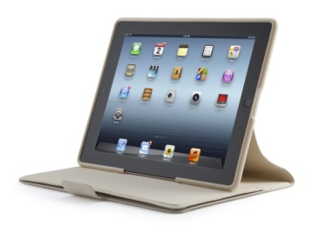
To apply for the position as a digital leader, please create a presentation using digital technologies.

This can be presented in the form of:
- PowerPoint Presentation
- Book Creator
- Word/Publisher document or anything else you are interested in!
- Sway You Decide!
- Video
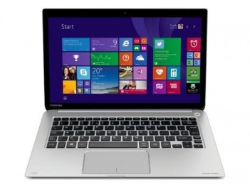
- Animation

Questions to answer and include in your presentation:
- What does a digital leader mean to you?
- Why do you want to become a digital leader?
- What skills do you have that will make you a good digital leader?
- What part of digital literacy is your favourite that you enjoy to do at home and/or at school?
Once you have completed your application form, I would like you to email your application to Mrs Macdonald: ed055amacdonald@glow.sch.uk
I look forward to receiving your applications and cannot wait to begin our technologies journey at Killermont Primary School!

